REVISION - PAST SIMPLE
1. Doplň was nebo were.
I______________in hospital last week. You _______late yesterday. _______the cat in its basket? _____they in England two years ago? Which bus_____you on? Claire and Jane____________at the shops. We________at a football match. He________at the cinema. You________at dance class. John _________in bed.
2. Udělej z kladných vět záporné věty.
a) Emma and Jamie were at the doctor.
b) Sue was at the shops.
c) Liam was at the swimming pool.
d) We were in the garden.

3. Vytvoř otázky podle příkladu.

Ex. I went to the dentist´s yesterday. (Where)
Where did you go yesterday?

- Tim went to London last week. (Where)

- I hit a wall and fell off my bike. (Why)

- Emma read six books last month. (How many)

- I had a shower at eight o´clock. (When)

- I did my homework last night. (What)

4. Najdi ve větách chyby.

- Peter and David was at a party last night.

- Where were it?

- I weren´t at school yesterday.

- No, we were on holiday.

- Was there lots of people there?

5.Sestav větu. Do vět doplň was nebo were.

- Home/Victoria/at/Ben/on/and/Saturday

- I/ill/last week

- Dan/and/Jamie/at the cinema

- All/the/great/bands

- Opakujeme zvířata. Do tajenky doplň slovíčka.

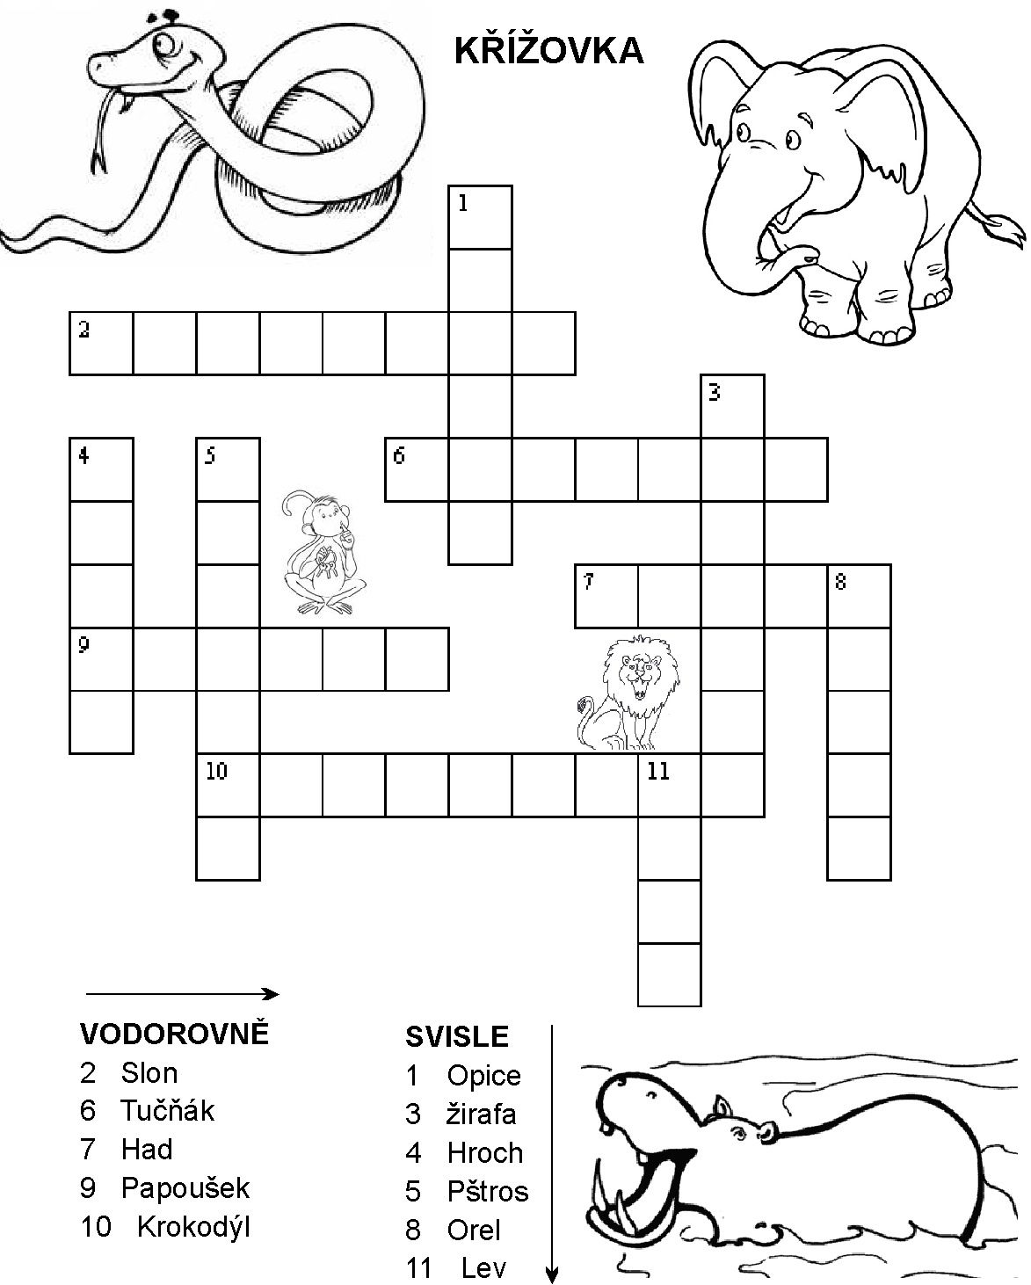

- V osmisměrce najdi 17 dopravních prostředků. Dopravní prostředky přelož.
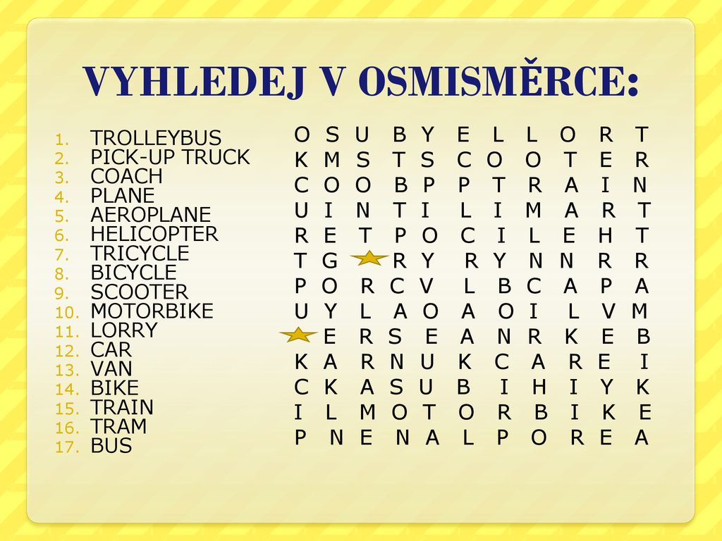

Opět trénujeme poslech. Najdi si písničku od Demi Lovato - Let It Go (from "Frozen") a doplň slova.

Let It Go
Let it go, Let it go
Can’t hold it back ……………………………
Let it go, Let it go
Turn ………………….and slam the door
The …………….. glows white on the mountain tonight
Not a footprint to be seen
A kingdom of isolation and it looks like I'm …………………
The wind is howling like this swirling storm ……………………………..
Couldn’t keep it in, heaven knows I tried
………………… let them in, don’t let them see
Be the good girl
You always had to …………………..
Conceal, don’t ……………………..
Don’t let them know
Well, now they know
Let it go, Let it go
Can’t hold it back ……………………..
Let it go, Let it go
Turn my back and slam the ………………………
And here I stand
And here I'll stay
Let it go, Let it ………………..
The cold never bothered me anyway
It’s funny how …………………distance
Makes everything seem……………………
And the fears that once controlled me
Can’t get to me ………………………
Up here in the cold thin air
I finally can breathe
I know I left a life blind………………….
I’m too relieved to grieve
Let it go, Let it go
Can’t hold it back ………………..
Let it go, Let it go
Turn my back and slam the ………..
And here I stand
And here I’ll stay
Let it go, Let it …………………
The cold never bothered me …………………..
Standing frozen
In the life I’ve chosen
…………. won't find me
the past is so behind me
Buried in the …………………..
Let it go, Let it go
Can’t hold it back …………………….
Let it go, Let it go
Turn my back and slam the ……………………..
And here I stand
And here I’ll stay
Let it go, Let it…………………..
The cold never bothered me ……………………
Let it go
Let it go, Let it go
Let it go

- Přečti si text Clara´s holidays. Na základě textu se rozhodni, zda jsou věty pod textem pravdivé (true) či nepravdivé (false).

We usually go to the beach for our summer holidays because we love the sun and we love swimming. You can always do a lot of sports on the beach. We all like sports. Mum and Dad play a lot of tennis and they go windsurfing. My brother is learning to windsurf, but Dad says I am too young. He´s teaching me tennis and I like it. My brother´s favourite sport is football. On holiday, we always try new sports. Last January, I heard my mum talking to my dad. „I want to go to London on holiday this year“ she said. I wasn´t happy, but Mum and Dad never listen to me so we went to London in July. I didn´t like it. The weather was warm and sunny, but we didn´t do any sports. We visited lots of museums and old buildings.

- Clara normally goes to the beach in the summer.
- Clara´s family go on beach holidays because they like the sun and they like swimming.
- Clara´s parents play tennis.
- Clara´s dad teaches her to windsurf.
- Clara´s brother likes football.
- Clara wanted to go to London on holiday.
- Clara´s family went to London in January.
- They visited museums in London.
- Clara enjoyed her holiday in London.

