Opakování – Past simple

1. Najdi chyby v následujících větách.
a) Did you bought a newspaper yesterday?
b) You listen to the news last night?
c) Did you lived in Poland?
d) Do you listen to your parents when you were young?

2. Dej slova do správného pořadí a sestav větu v Past simple.
work/yesterday/I/day/all
she/to the radio/ listen/ at breakfast
to the airport/we/not drive
Tina/start/at 6 o´clock/the class

3. Doplň slovesa v Past simple.
I______________(open) the door. They_________________(visit) my parents. She___________(marry) with my brother. He___________(come) to Italy last week. They _______________(get) a new house. We____________(cook) lunch yesterday. He_________________(stop) the car. Nick____________(drive) to work. She_________________(not, go) shopping. He_______________(play) his guitar. I_________(watch) TV. Who_______(buy) a model plane? _____she_____(go) to London? They______(stop) the car. I_______(stay) in bed for three days. ______you_______(eat) your sandwich?. _________they________(go) to Lake Balaton? You_________(write) a letter. He______________(not, be) on holiday last week. _______(be) we in England two years ago? She__________(be) at the cinema on Monday. They____________(be) out yesterday. __________you_______________(buy) a newspaper yesterday? ______you_______(like) the concert? ________you____________(have) a nice weekend? _________you____(live) in Poland?

4. Sestav otázku v Past simple. Napiš krátké odpovědi podle pravdy.
1. Shakespeare/write/Romeo and Julie?
2. Alexander Graham Bell/ invent/ email?
3. Yuri Gagarin/ travel/ to the moon?
4. Beethoven/ write/ rock songs?

5. Minulý čas sloves – křížovka
Across
2. plaval
4. rozbil
5. zapomněl
7. měl
9. přišel
11. chtěl
13. ztratil
Down
1. dal, dával
2. ukradl
3. odešel
4. kousl
6. shrábnul
8. říkal
10. běhal
12. vzal

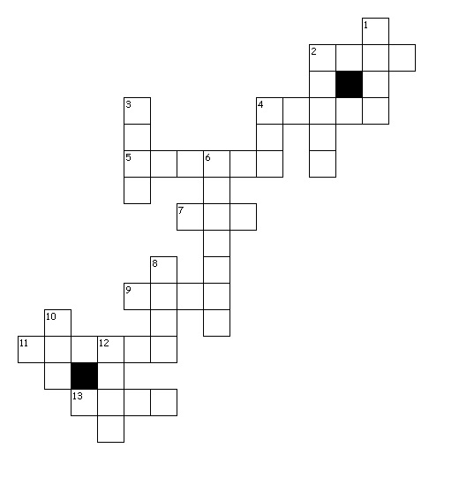

6. Trénujeme poslech! Na youtube si najdi písničku Demons a na základě poslechu doplň vynechaná slova.

Demons
When the days are………………..
And the cards all fold
And the saints we see
Are all made……………………
When your dreams all fail
And the ones we hail
Are ……………………………………of all
And the blood's run stale
I wanna hide the truth
I wanna shelter…………………
But with the beast ……………………..
There’s nowhere we can hide
No matter what we breed
We still are made of greed
This is my kingdom …………………
This is my kingdom……………………
When you feel my heat
Look into my ……………………..
It’s where my demons hide
It’s where my demons hide
Don’t get too ……………………….
It’s dark inside
It’s where my demons hide
It’s where my demons hide
When the curtain’s call
Is the …………………………… of all
When the lights fade out
…………………………. the sinners crawl
So they dug your grave
And the masquerade
Will ……………………………… calling out
At the mess you've …………………………..
Don’t wanna let you down
But I am hellbound
Though this is all …………………………..
Don’t wanna hide the truth
No matter what we breed
We still are made of greed
This is my kingdom …………………..
This is my kingdom ………………….
When you feel my heat
……………………….. into my eyes
It’s where my demons hide
It’s where my demons hide
Don’t get too …………………………….
It’s dark inside
It’s where my demons hide
It’s where my demons hide
They say it's what you …………………………..
I say it's up to fate
It's woven in my soul
I …………………………. to let you go
Your eyes they shine so bright
I wanna save that light
I can't escape this………………………..
Unless you show me how
When you feel my heat
…………………………. into my eyes
It’s where my demons hide
It’s where my demons hide
Don’t get too …………………………..
It’s dark inside
It’s where my demons hide
It’s where my demons hide

7. Co jsi dělal minulý týden?
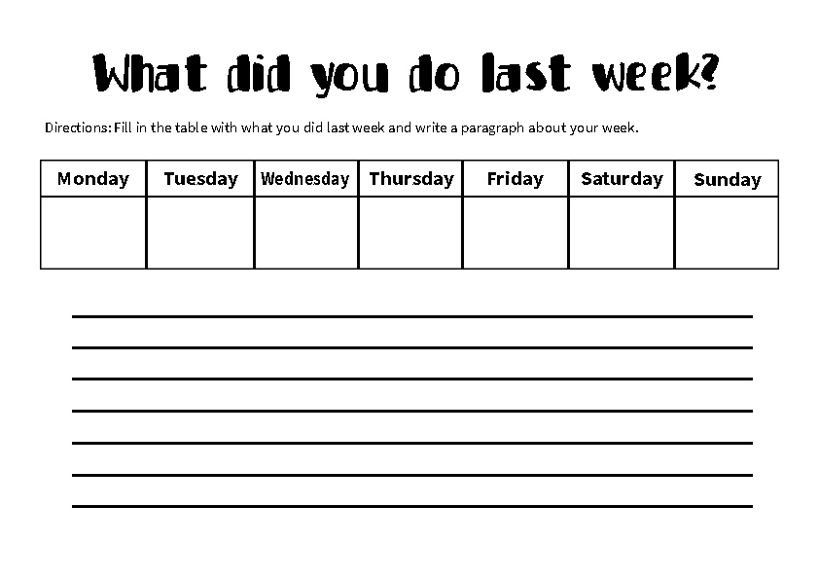
8. Co dělal John včera? Popiš obrázky v minulém čase:
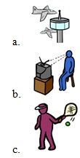

9. Přečti si text a odpověz na otázky.
Hello! My name is Rob. I´m twelve years old. I live in Skočice. In the morning I take the bus to school at half past seven. My school starts at ten to eight. My lessons usually finish at twenty past one. After lunch I have my tennis lessons on Tuesdays and Thursdays in Přeštice. I always do my homework in the afternoon. After dinner I sometimes walk with my dog. I often take the rubbish out. Then I feed my dog and I never wash up because I don´t like it. I usually watch TV and I go to bed at half past nine.
How old is Rob?_____________________________________________________
___________________________________________________________________
When does he take the bus to school?___________________________________
___________________________________________________________________
What does he do on Tuesdays and Thursdays? ___________________________
___________________________________________________________________
Where does Rob live?_________________________________________________
___________________________________________________________________
How often does he walk with his dog?___________________________________
___________________________________________________________________
What does he do in the evenings?______________________________________

