FACE

1 Vyber správné slovíčko, šipkou ho přiřaď k obrázku a na linku ho opiš.

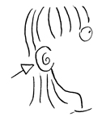 __________________
MOUTH

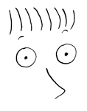 __________________
HAIR

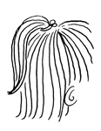 _________________
NOSE

EYE
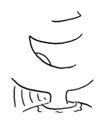

________________

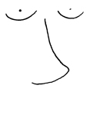 _________________
EAR

2 Doplň chybějící písmenka

L__ N G

S__ O R T

__ L O N D

D A __ K

3 Přiřaď věty šipkou ke správnému obrázku

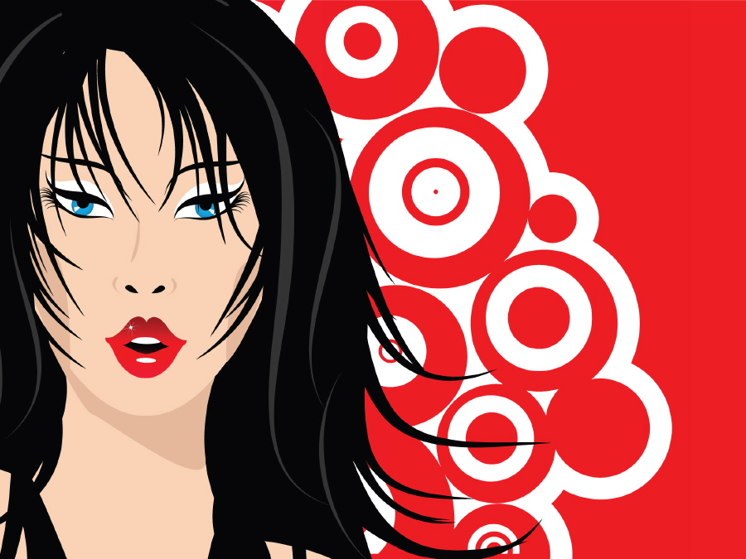
He/She has got long hair.

He/She has got glasses.

He/She has got blond hair.

He/She has got dark hair.

He/She has got small eyes.

He/She has got big ears.

4 Vyhledej 11 slovíček

H | A | I | R | E | P | E | P | Z | Q
W | S | E | H | K | A | I | A | E | B
J | A | E | E | M | R | R | C | E | L
X | A | P | Y | A | O | A | N | S | O
D | S | Q | E | Z | F | U | D | U | N
D | H | O | L | O | N | G | T | T | D
A | O | G | E | S | O | N | Y | H | L
W | R | K | U | U | F | U | D | T | X
S | T | D | B | I | T | V | R | O | A

Porovnejte dvojice obrázků, použijte části těla a výrazy:
SHE HAS GOT (ona má), HE HAS GOT (on má), IT HAS GOT (ono má) – používá se u zvířete

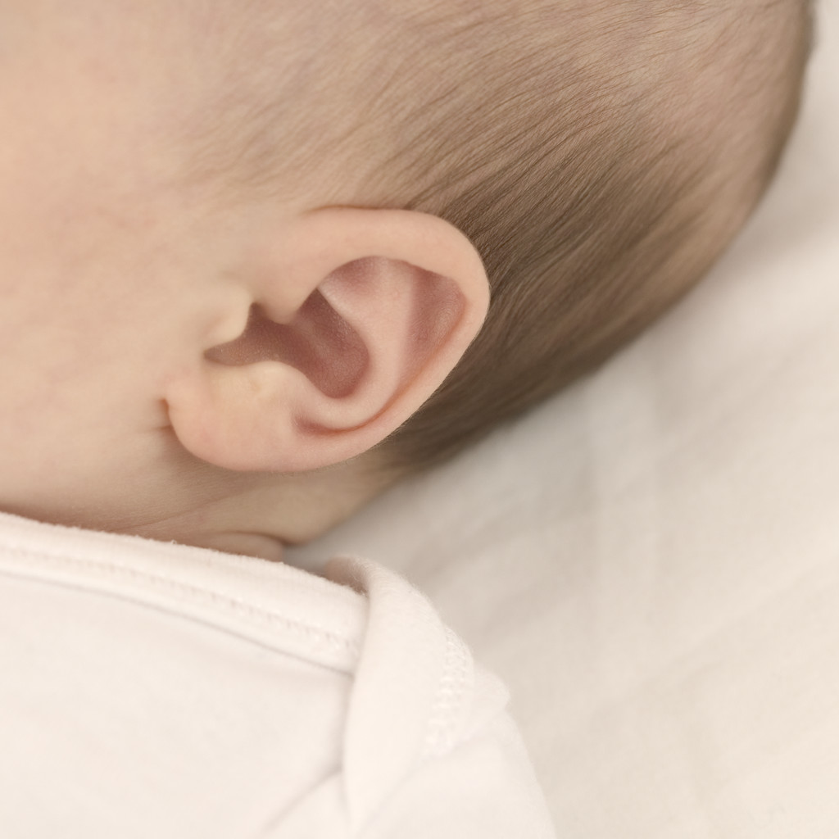
UŠI
MALÉ
VELKÉ

___________________________________________________________________________
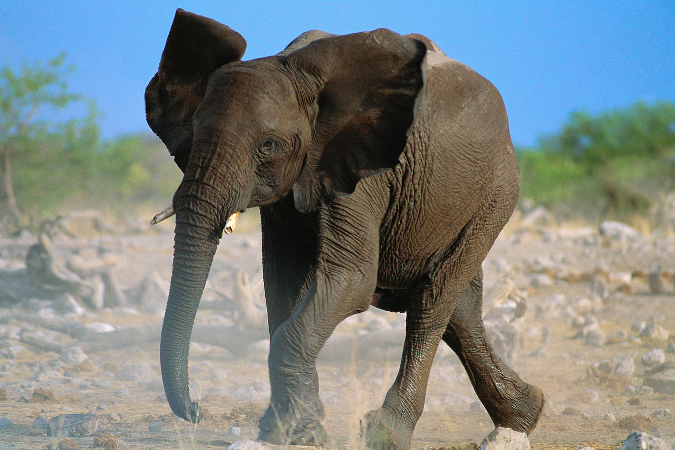
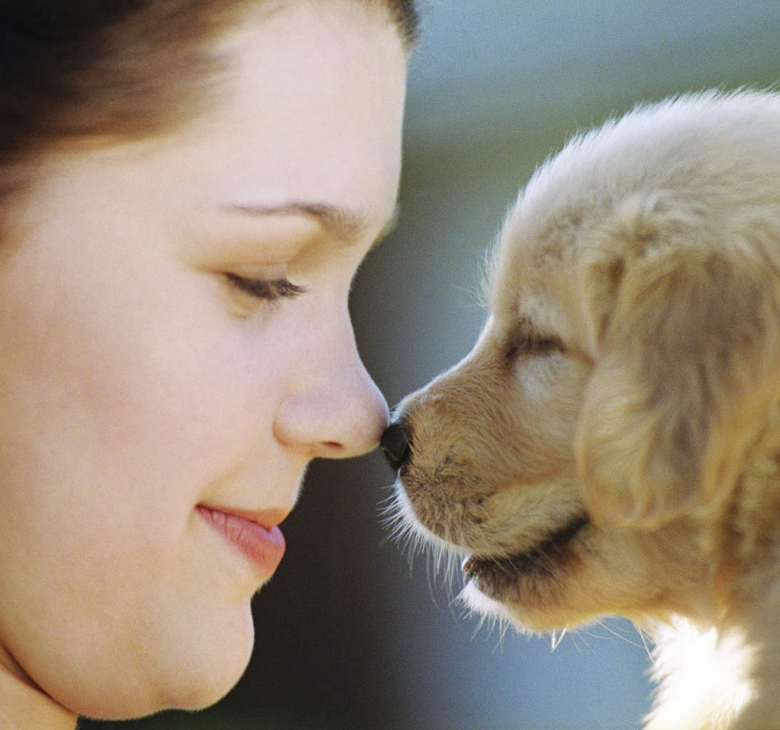
NOS
MALÝ
VELKÝ

___________________________________________________________________________

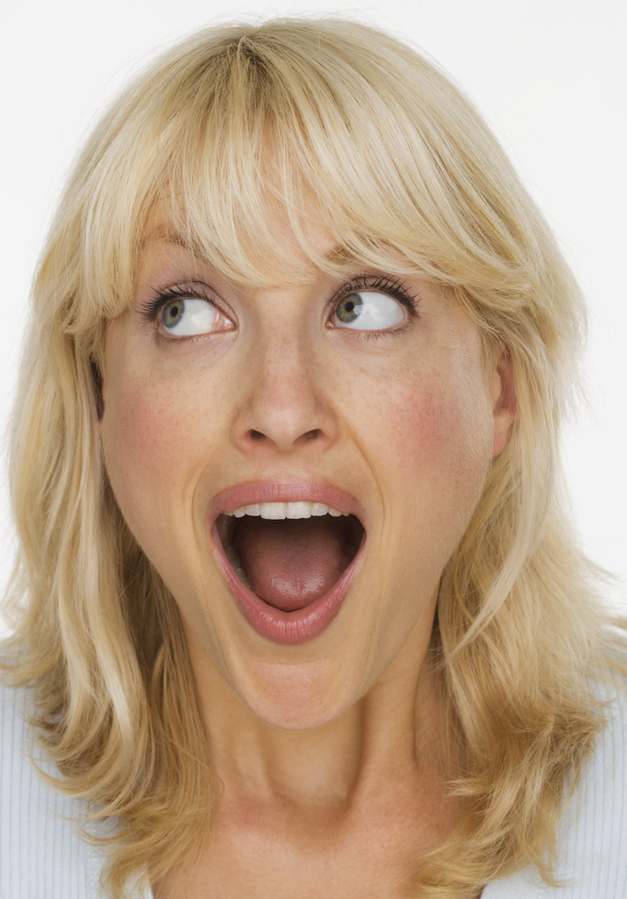
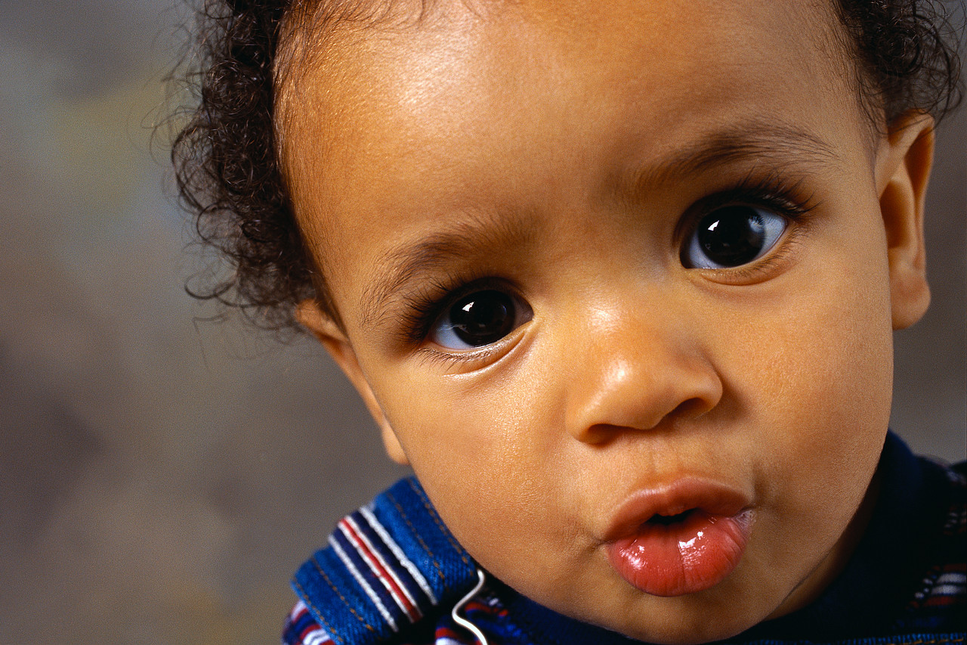

ÚSTA
MALÁ
VELKÁ

___________________________________________________________________________

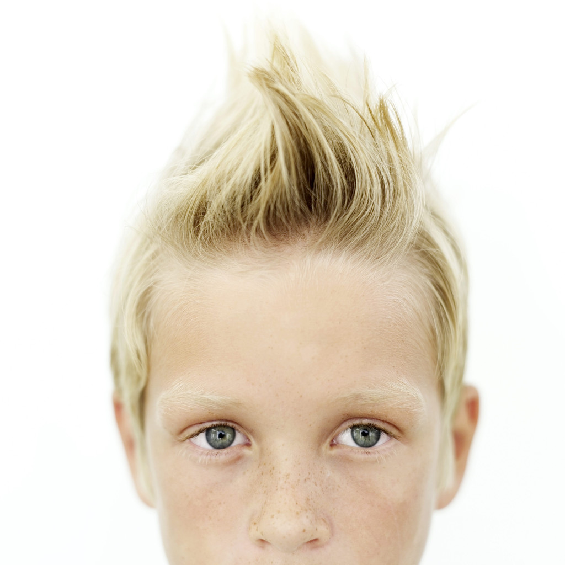
VLASY
DLOUHÉ
KRÁTKÉ
BLOND
TMAVÉ

___________________________________________________________________________
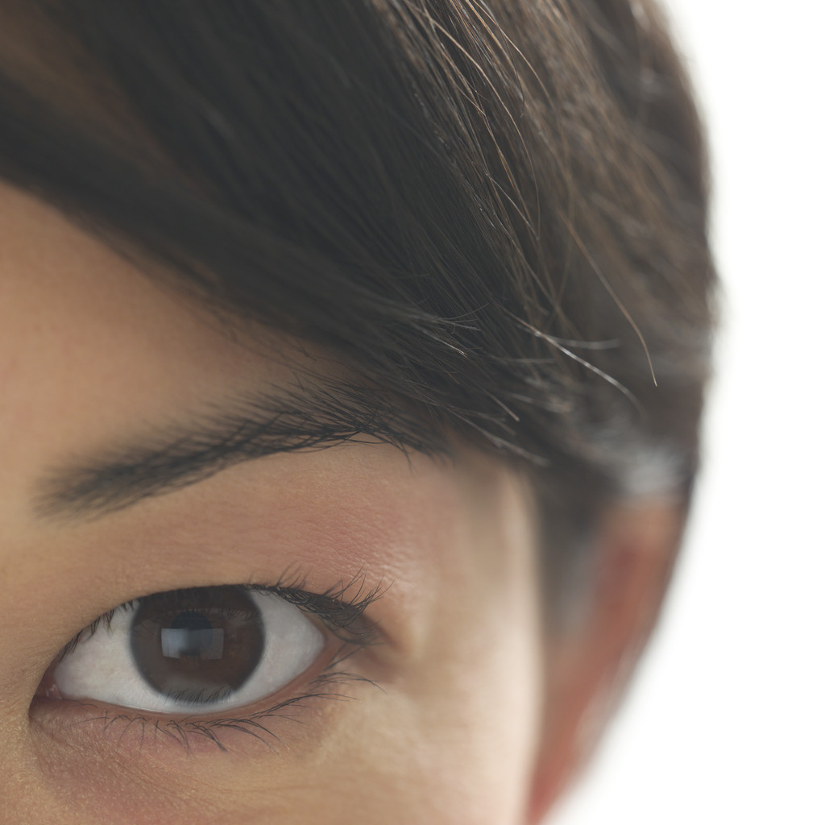
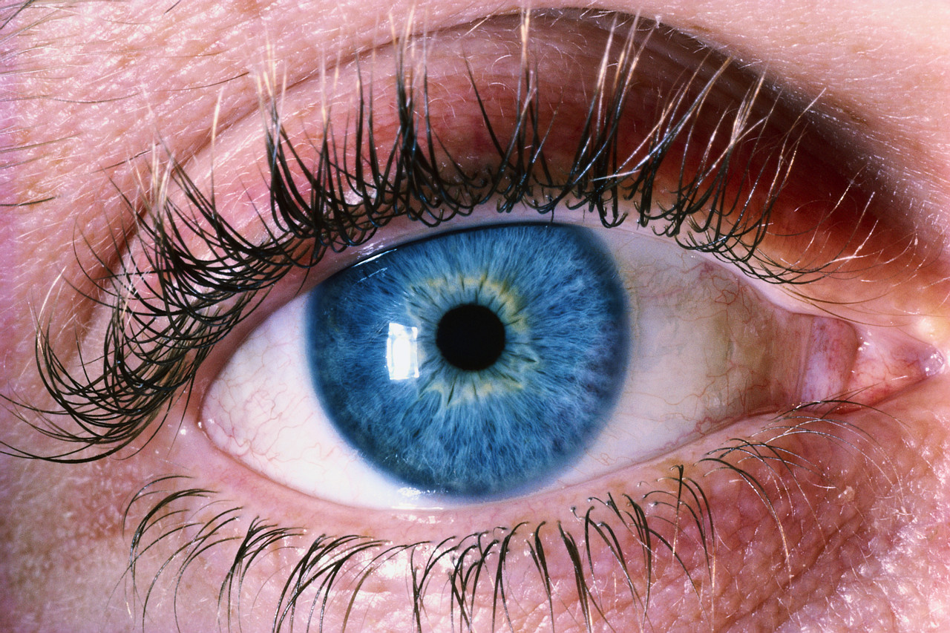
OČI
MODRÉ
HNĚDÉ

___________________________________________________________________________

ŘEŠENÍ - FACE

1 Vyber správné slovíčko, šipkou ho přiřaď k obrázku a na linku ho opiš.

___EAR______________
MOUTH

____EYE______________
HAIR

___HAIR_____________
NOSE

EYE

____MOUTH________

___NOSE___________
EAR

2 Doplň chybějící písmenka

L O N G

S H O R T

B L O N D

D A R K

3 Přiřaď věty šipkou ke správnému obrázku

He/She has got long hair.

He/She has got glasses.

He/She has got blond hair.

He/She has got dark hair.

He/She has got small eyes.

He/She has got big ears.

4 Vyhledej 11 slovíček

H | A | I | R | E | P | E | P | Z | Q
W | S | E | H | K | A | I | A | E | B
J | A | E | E | M | R | R | C | E | L
X | A | P | Y | A | O | A | N | S | O
D | S | Q | E | Z | F | U | D | U | N
D | H | O | L | O | N | G | T | T | D
A | O | G | E | S | O | N | Y | H | L
W | R | K | U | U | F | U | D | T | X
S | T | D | B | I | T | V | R | O | A

Hair, long, nose, head, face, blond, mouth, short, ear, dark, eye

Porovnejte dvojice obrázků, použijte části těla a výrazy:
SHE HAS GOT (ona má), HE HAS GOT (on má), IT HAS GOT (ono má) – používá se u zvířete
UŠI
MALÉ
VELKÉ

It has got big ears. It has got small ears.
________________________________________________________________________

NOS
MALÝ
VELKÝ

It has got small nose. It has got big nose.
________________________________________________________________________

ÚSTA
MALÁ
VELKÁ

She has got big mouth. He has got little mouth.
________________________________________________________________________

VLASY
DLOUHÉ
KRÁTKÉ
BLOND
TMAVÉ

He has got short blond hair. She has got long dark hair.

OČI
MODRÉ
HNĚDÉ

She has got brown eyes. She has got blue eyes.
________________________________________________________________________
Použité zdroje: Obrázky z CD k učebnici Chit Chat 1 a Klipart

