Revision

1. Přelož
Dvě děti jedno dítě
Jeden zub dva zuby
Tři muži jeden muž
Čtyři ženy jedna žena
Myš dvě myši

2. Present simple nebo present continuous?
We____________(go) here every Tuesday and Friday. Phil and Justin usually ________(play) basketball. Boys _____________(leave) the table now. They _____________(wait) to get into the gym now. Every summer we___________________(go) to Scotland. I_________(use) the computer every day. She___________(send) me an e-mail now. Just a minute. I________(put) my jacket on. In this photo Sophie ____________________(sit) in the garden. He______(live) in London. She________(do) her homework now. I ______(play) table tennis on Friday. Tony______________(get up) at eight o´clock every day. She________(have) a shower at the moment. I_____________(play) a computer game at the moment. We________(not go) shopping. Thomas_______(clean) his teeth every day. Georgia _______(wear) her new trousers today. We_______(go) to school every Monday.

3. Napiš 5 místností v domě či v bytě

4. Napiš 5 věcí nebo nábytku, které mohou být v domě

5. Vyber vhodné zájmeno dle smyslu věty
They/them see her on Monday. She/her loves him. I/Me live in Městec Králové. He/him likes a dance. She/her name is Dana. I/me love this programme. She plays they/them every day. Do you want to come with we/us? Oh, I like they/them. He/him is working in Canada.
- Přiřaď k sobě slova s opačným významem
Warm fair
Dark dirty
Long small
Big cold
Clean short

9.Utvoř otázky v přítomném čase průběhovém
a) Who/wear/sweatshirt?
b) Which/man/run?
c) What/Beyoncé/do?
d) Who/play/football?

10. Utvoř množné číslo podtržených podstatných jmen a věty přepiš.
1. The man is from Slovakia.

2. The girl is eleven.

3. The box is on the table.

4. Where is the tooth?

5. Is the mouse in the bag?

6. She is teacher.

11. Utvoř otázky
1. Maria is six.
2. You are from Britain.
3. Your name is Ben.
4. The books are on the table.
5. Tibor is in the football team.

12. Na základě definice napiš k větám odpovídající zvíře.
a) It lives in trees and likes bananas.
b) It isn´t a bird, but it can fly.
c) Your jumper comes from this animal – perhaps.
d) It is small, but isn´t a mouse. Children often keep it as a pet.
e) It is a very big and strong animal. You can find it in India or Africa.
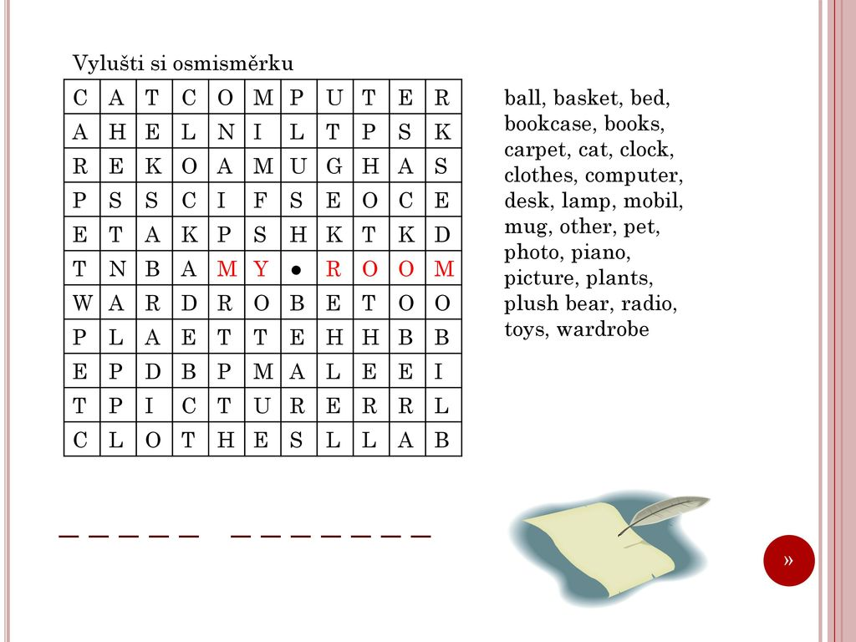

14. Trénujeme poslech! 😊 Na webu si najdi stránku youtube, zadej si tam písničku od Dana Bárty – On My Head. Poslechni si ji a doplň slova do textu.

Dan Bárta - On My Head
Lead my ……………..
In my own place
Ride up to ………….
Across the heaven
………………you say
You will drive …………
Meeting my …………….
Leaving the yard
……………………the night's burst
Never say ……………….
We freak, we burst
pasting from our ………………..
When I am standing on my ……………..
You are ……………………..
Now we don't have it we are mad
Guaranteed speedy romance
When I am standing on ……………..
You are …………………….
Now we don't have it we are mad
……………….round this speedy romance
You have ……………..to take a brake
Get up to find your …………………..
Someone lost you trust your soul
……………………..the right size and good measure
I am a tough guy from ………………….
My good will drives me ……………….
When I am standing on ……………….
You are …………………
Now we don't have it we are mad
……………roun this speedy romance
When I am standing on ……………..
You are ……………..
Now we don't have it we are mad
……………… round thisspeedy romance
When I am standing on ………………..
You are ………………..
Now we don't have it we are mad
………………..round this speedy romance
When I am standing on …………
You are ……………….
Now we don't have it we are mad
………………..round this speedy romance.

